HOOK FLOWER & PRODUCE SHOW rules

      - All exhibits must be home made or home/allotment grown.
- This event is an open show, exhibits are welcomed from all. Exhibits from local professional gardeners must be grown in their own garden or allotment.
- No entry fees.
- An exhibitor may stage only one entry per class, except Class 29 when 2-5 of each type may be exhibited.
- Exhibits may only be staged between 09.30 and 11.00 am. The hall will be closed for judging at 11.15 am.
- Exhibitors may not move any entry by another exhibitor.
- No exhibitor should show their name on their entry.
- Plates will be provided but not vases. Please label base of any container with name and telephone number.
- Prize giving 4.15 pm. No exhibits to be removed until after the end of the prize giving.
- Rosettes will be awarded for entries marked *.
and for the best entry in categories marked *.
Best in Show will receive the Hortus Loci Trophy.
- Closing date for entry lists is midnight, Wednesday, 4 September 2019.
12. All craft entries should be of new, unused quality and not entered in previous years.

Additional entry forms and enquiries to: Maggie Kirtley, 9 Goose Green, Hook, RG27 9QY / 01256 769432 show@hookinbloom.org
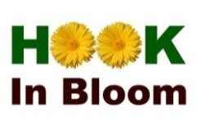
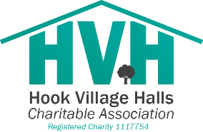
WITH

SPONSORSHIP BY
